**Step 1: Install Java 8 on Windows**

The Java development kit contains all the tools and software you need to run applications written in Java. It is a prerequisite for software solutions such as Apache Cassandra.

**Download Oracle JDK 8 (Java Development Kit)**

1. Visit the [official Oracle download page](https://www.oracle.com/java/technologies/javase/javase-jdk8-downloads.html) and download the Oracle JDK 8 software package.

2. Scroll down and locate the **Java SE Development Kit 8u251**for Windows x64 download link. The Java 8 download starts automatically after signup.

**Configure Environment Variables for Java 8**

It is vital to configure the environment variables in Windows and define the correct path to the Java 8 installation folder.

1. Navigate to This PC > Properties.
2. Select New in the System Variable section.

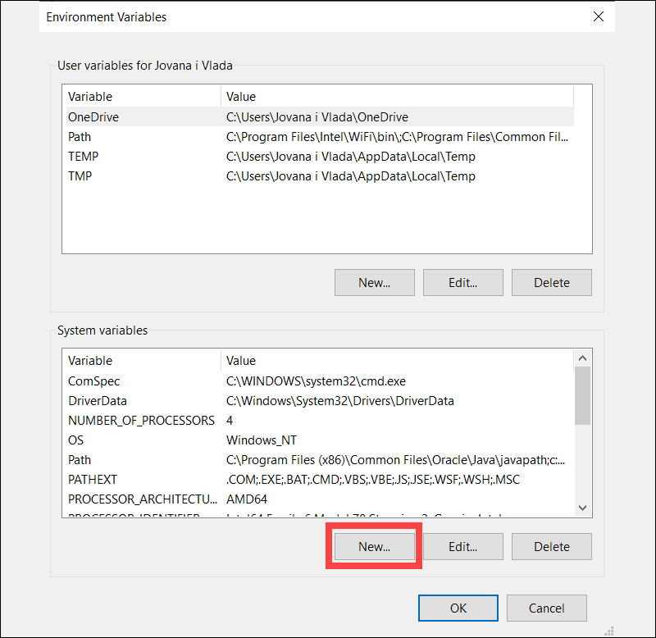

1. Enter JAVA_HOME for the new variable name. Select the Variable value field and then the Browse Directory option.

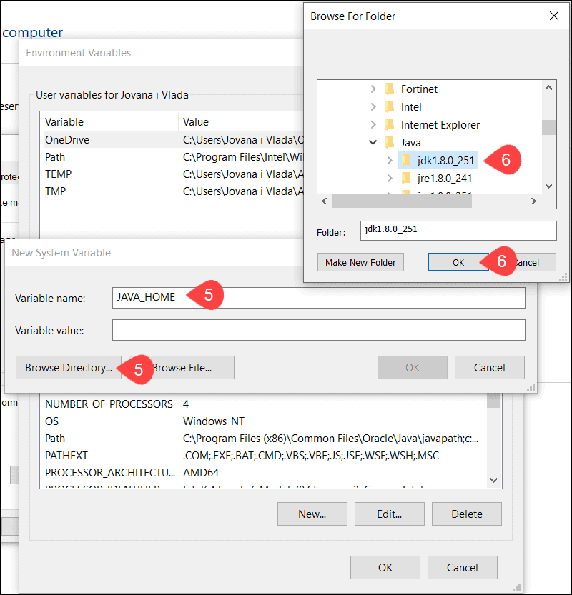

Once the correct path to the JDK 8 installation folder has been added to the JAVA_HOME system variable, click OK.

**Step 2: Install and Configure Python 2.7 on Windows**

Users interact with the Cassandra database by utilizing the **cqlsh** bash shell. You need to install Python 2.7 for **cqlsh** to handle user requests properly.

Edit Environment Variable for Python 2.7

1. Navigate to This PC > Properties.

**Configure Environment Variables for Cassandra**

Set up the environment variables for Cassandra to enable the database to interact with other applications and operate on Windows.

1. Go to **This PC** > **Properties.**

2. Type **CASSANDRA_HOME**for *Variable name***,**then for the*Variable value* column select the location of the unzipped **Apache Cassandra** folder.